

CONGRATS- YOUR #TTPRESET IS HERE!

Hey girl hey, it’s Torey here! Thank you for your mobile preset
purchase, I know you’ll be so happy with your photo edits
from here on out! Be sure to tag #TTpreset and
please feel free to reach out with any questions:
torey@toreystreasures.com

NO REFUNDS WILL BE GIVEN AFTER PURCHASE!

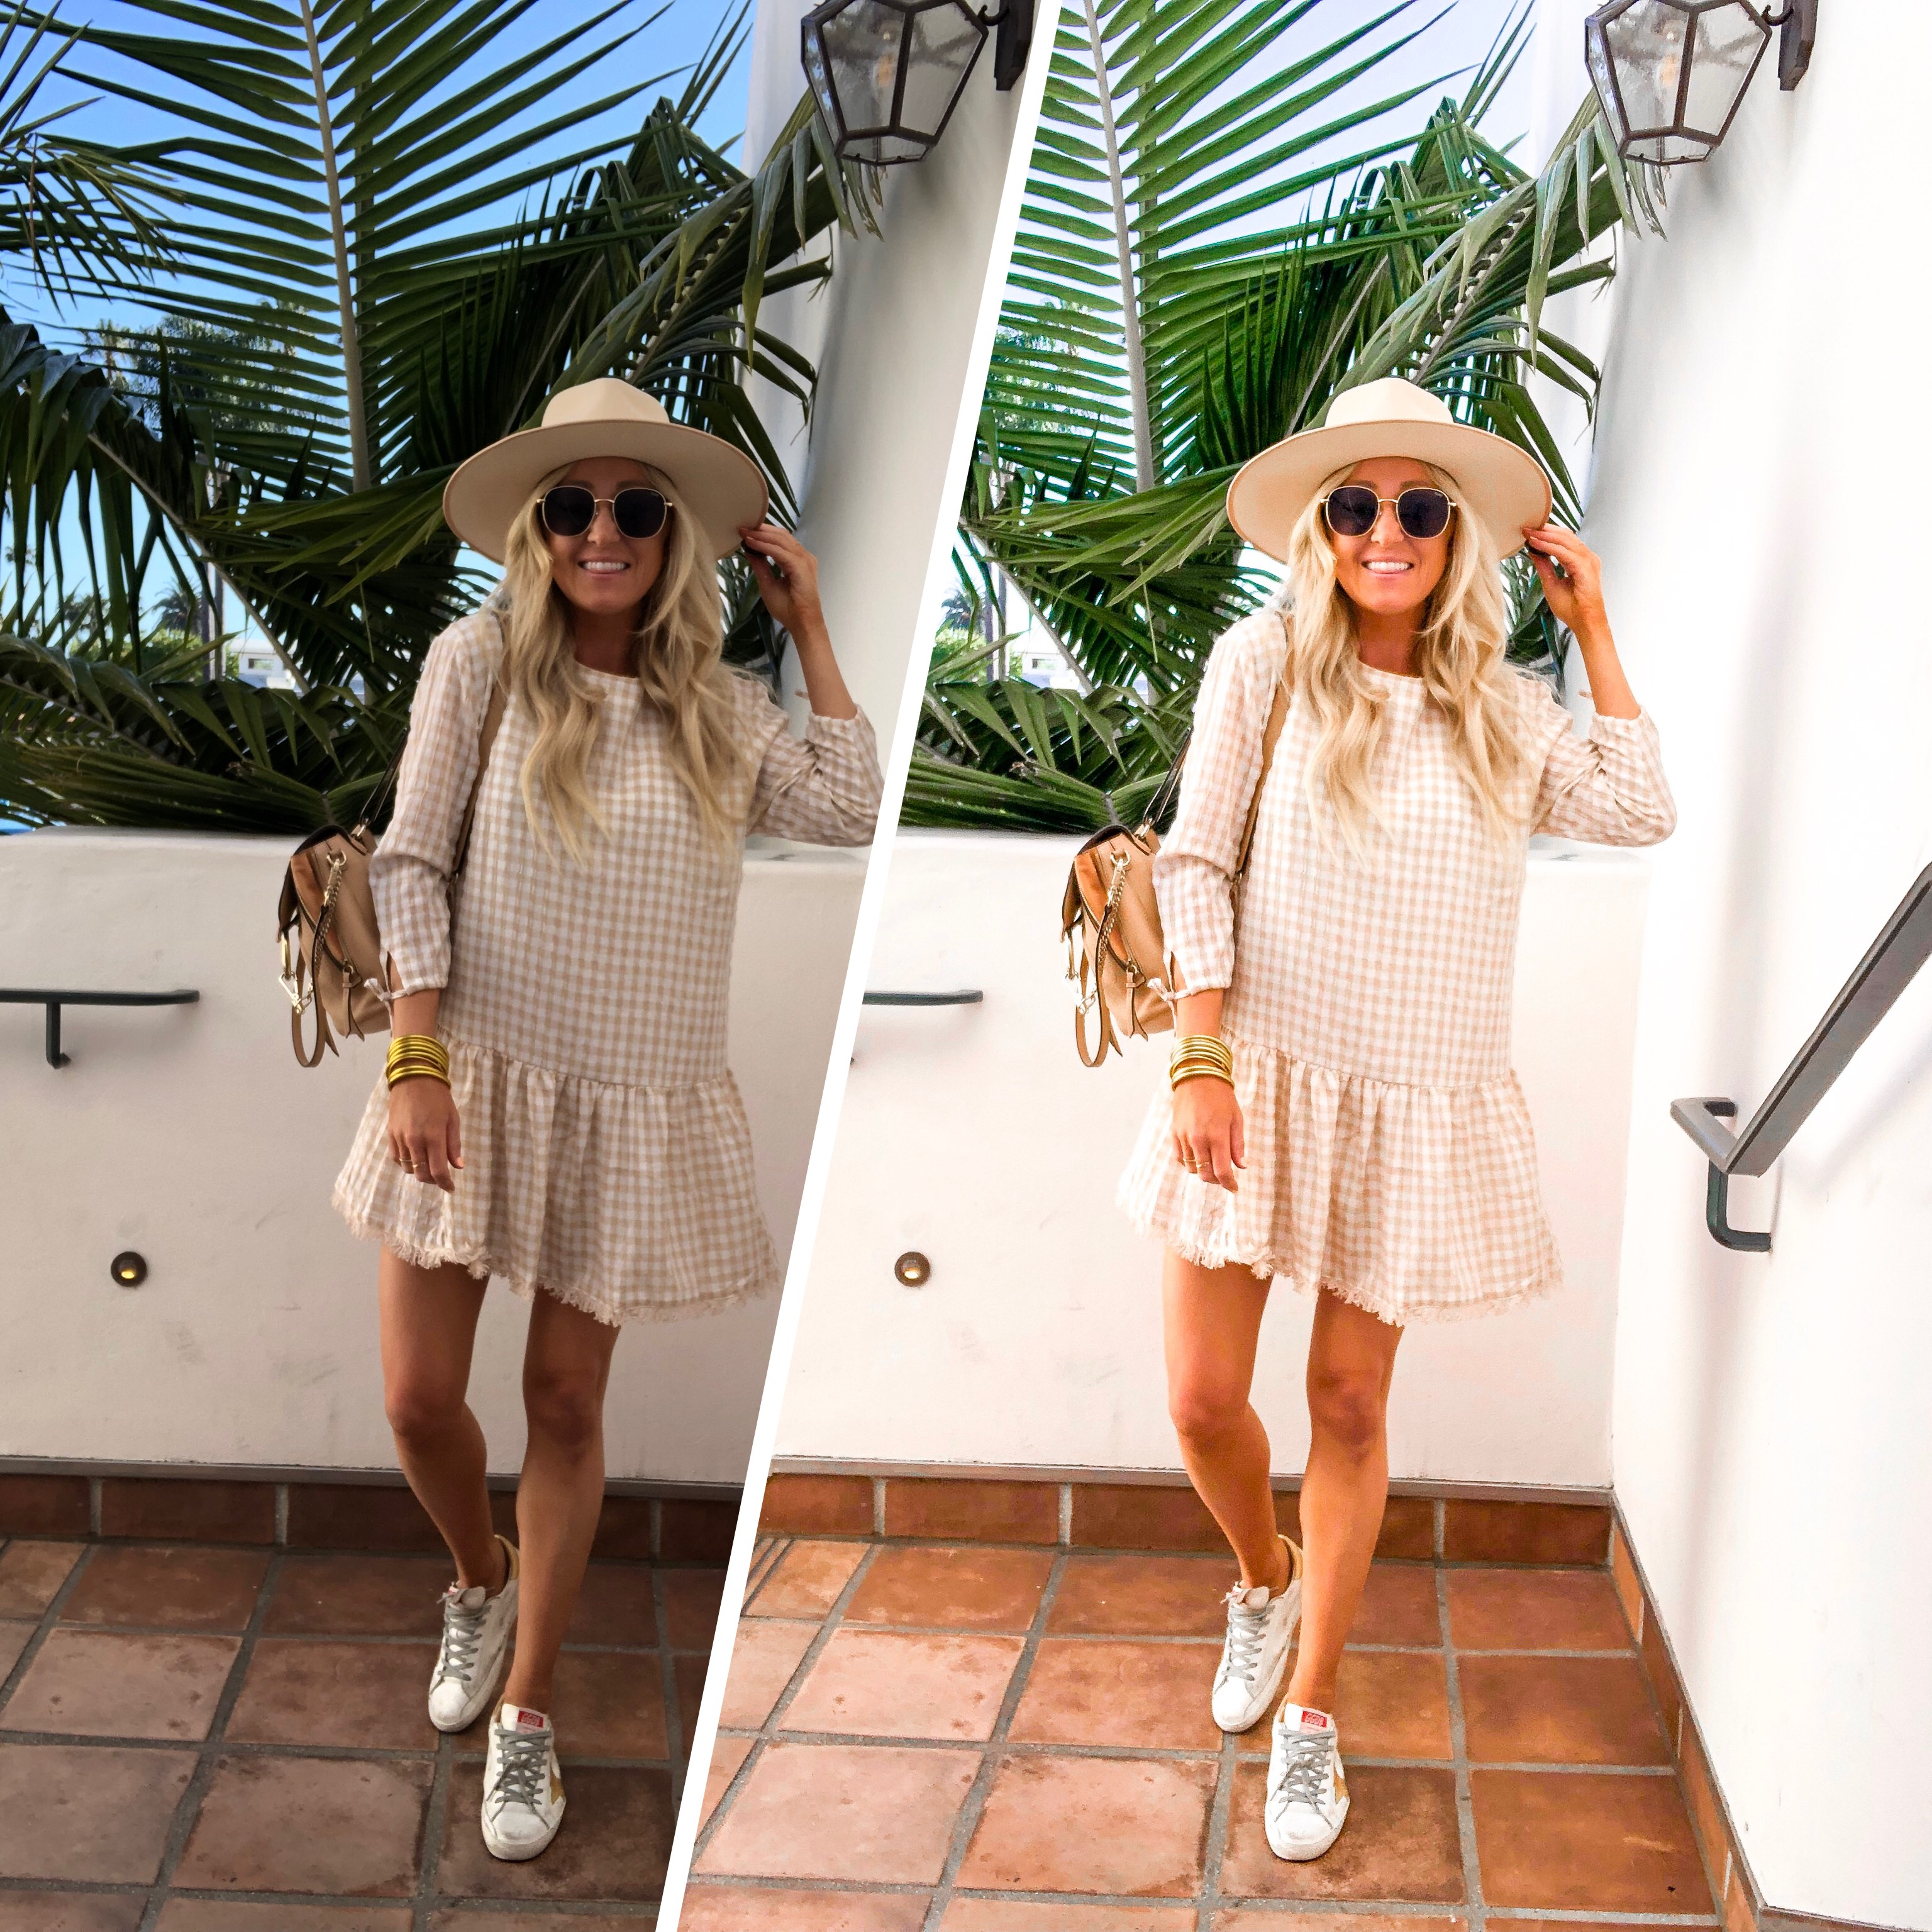

INSTRUCTIONS FOR DOWNLOADING + USING #TTPRESET:

- Before you can get your preset, make sure you have the FREE version of Lightroom downloaded to your phone!

- From your phone: check your email inbox to see if you’ve received an email from Shopify. It will look like the below. Click the link to get started with your #TTpreset

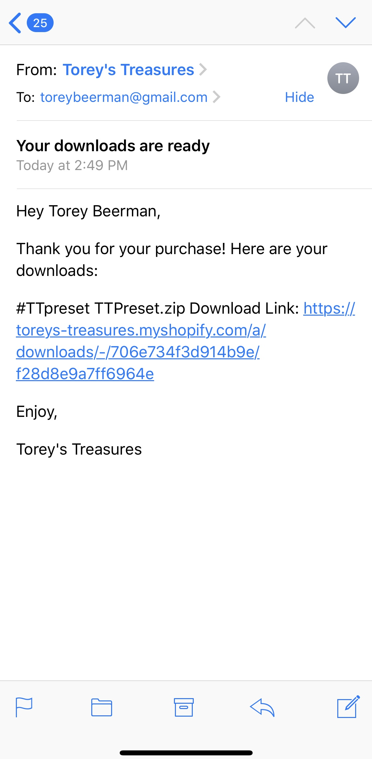

- A page will open up where you will see a before + after photo of me. Click the “download now” button.
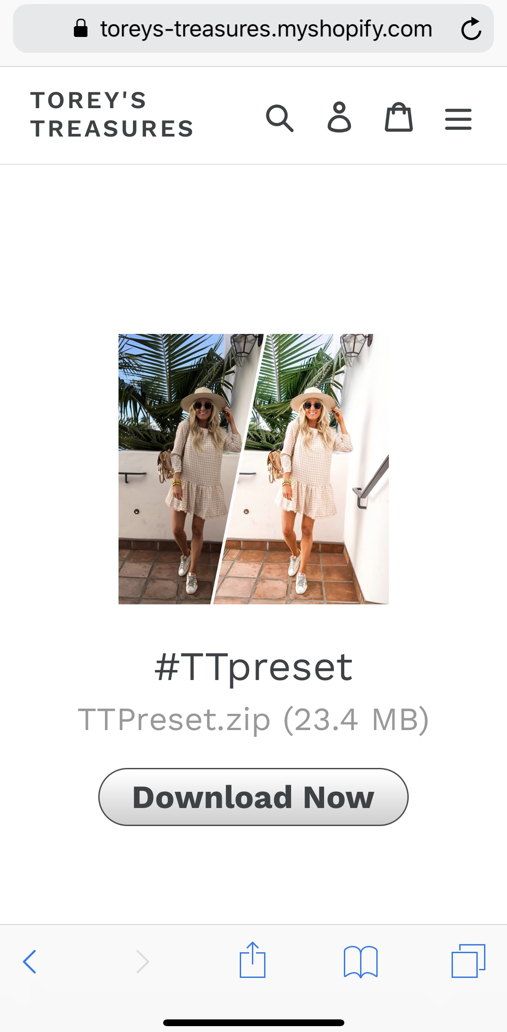

- Search for your File app on your phone to locate the .zip file I have sent you!
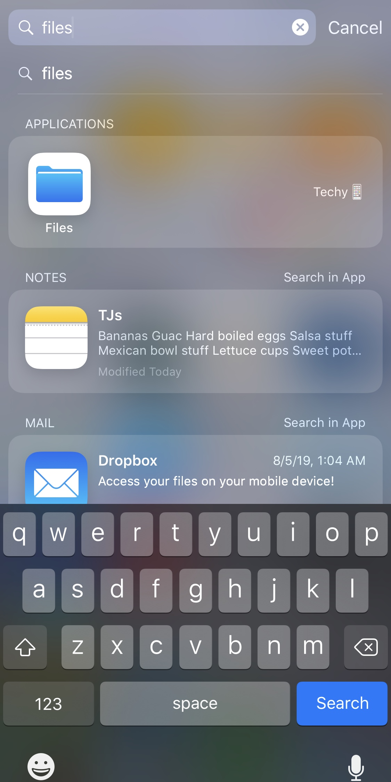

- I saved mine to my iCloud Drive, however, feel free to save yours to wherever you can easily locate it.
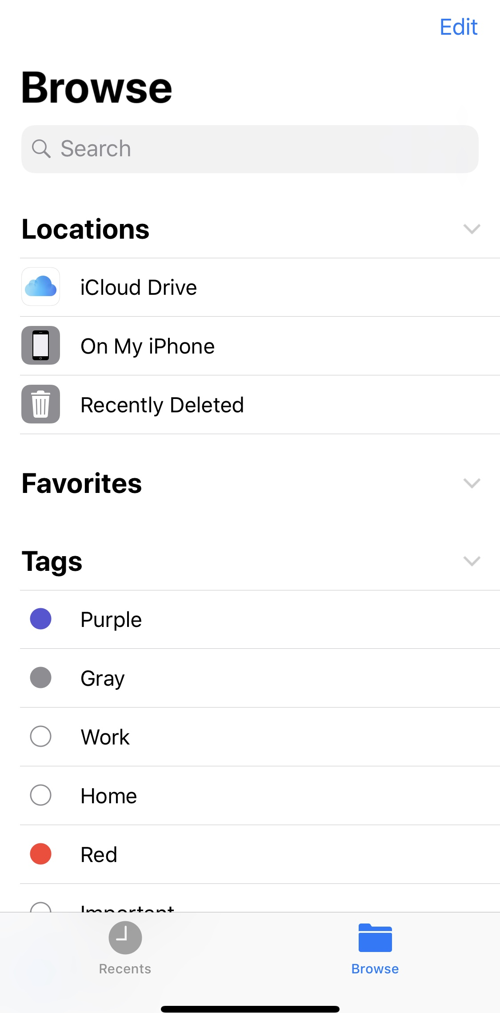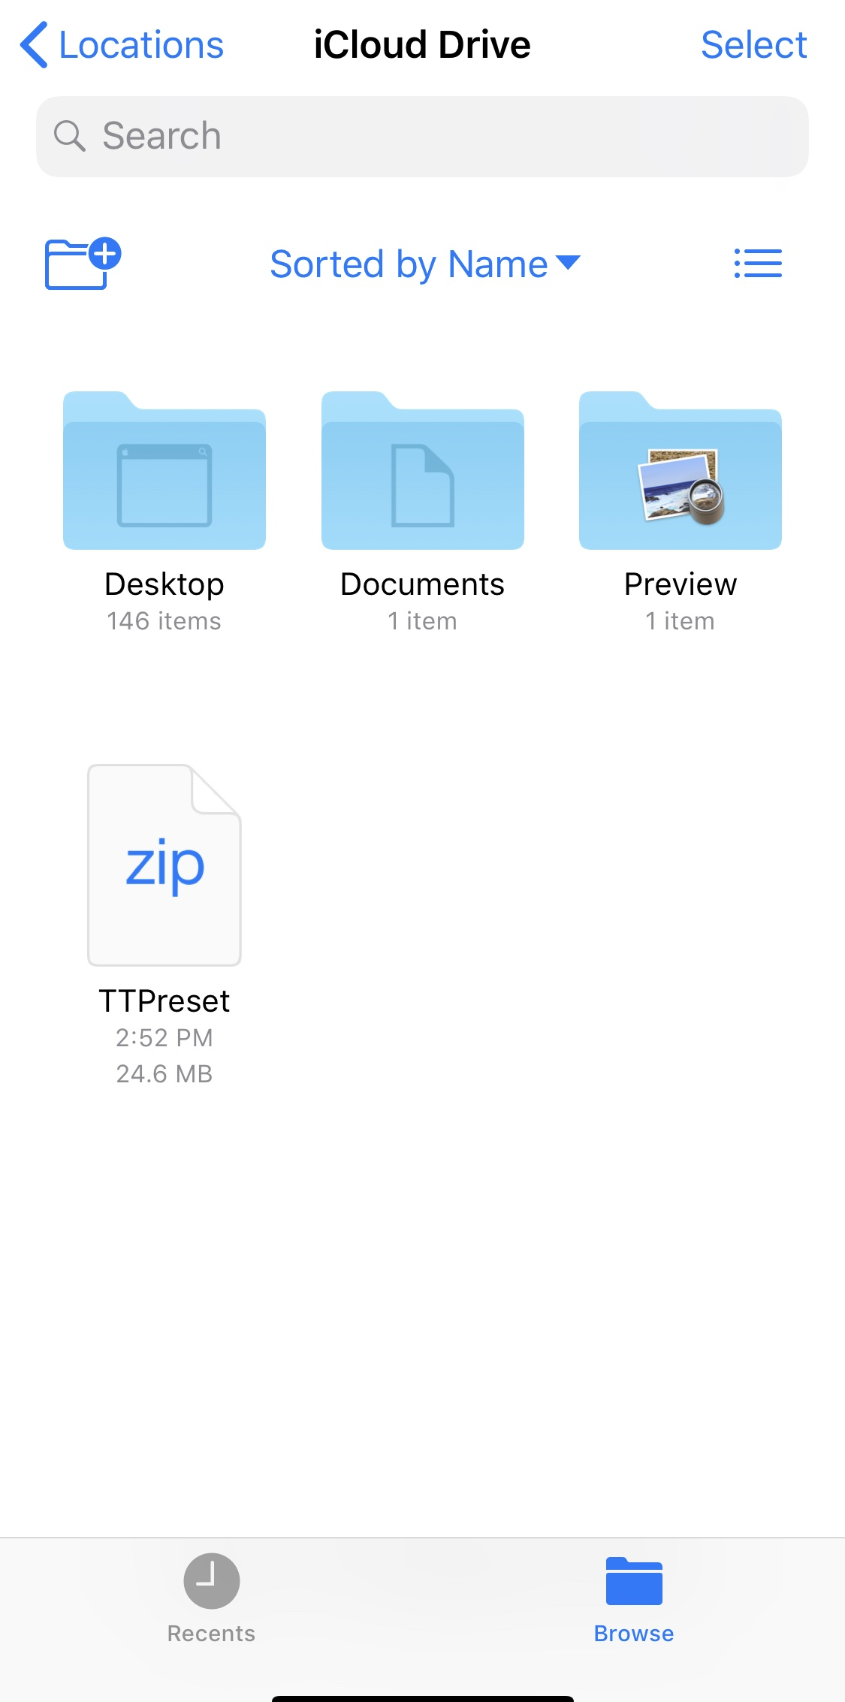

- Open the TTPreset .zip file!
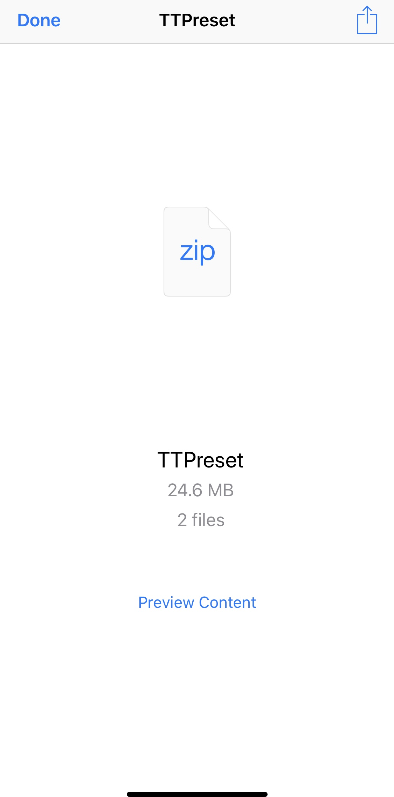

- Once opened, the file will say TT_Preset Adobe Raw Image. Tap the arrow button on the bottom left. “Tap the “save image” option
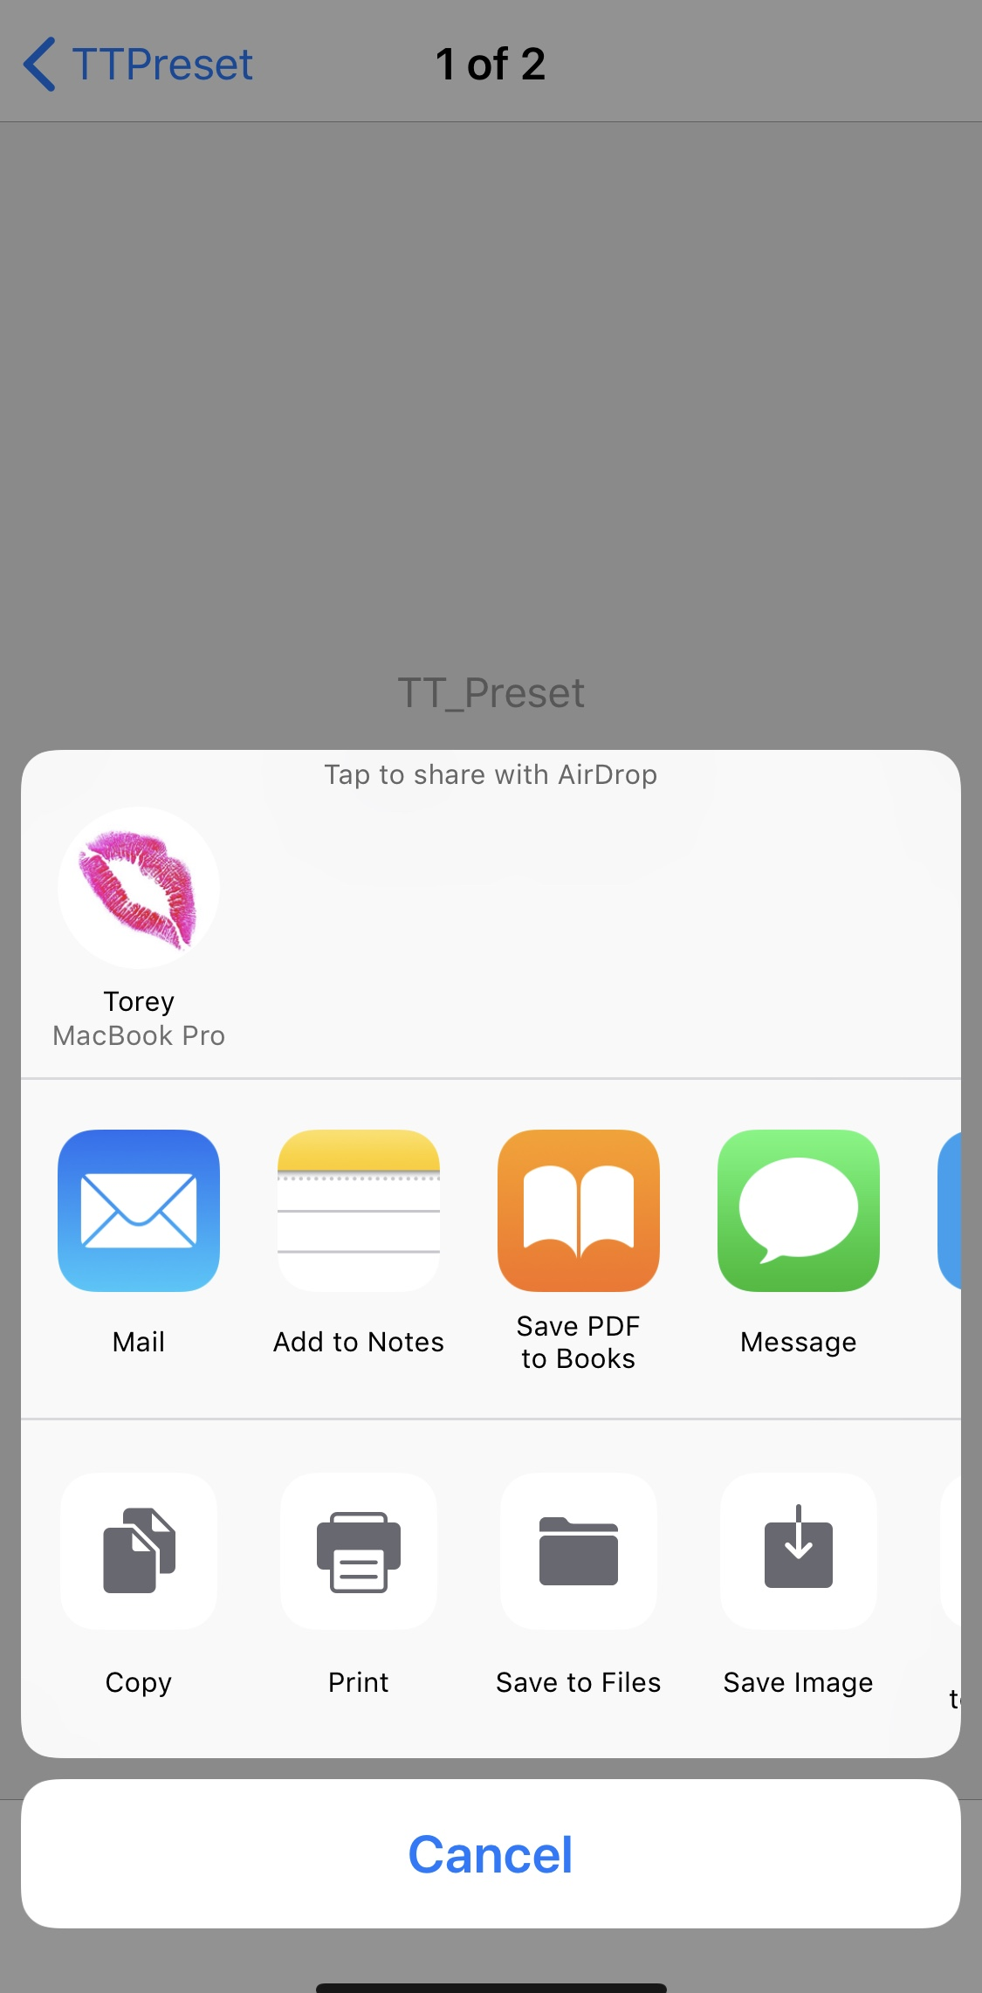

- Open the Lightroom mobile app. You’ll want to upload the blank .DNG file that you just saved to your camera roll into the Lightroom library.
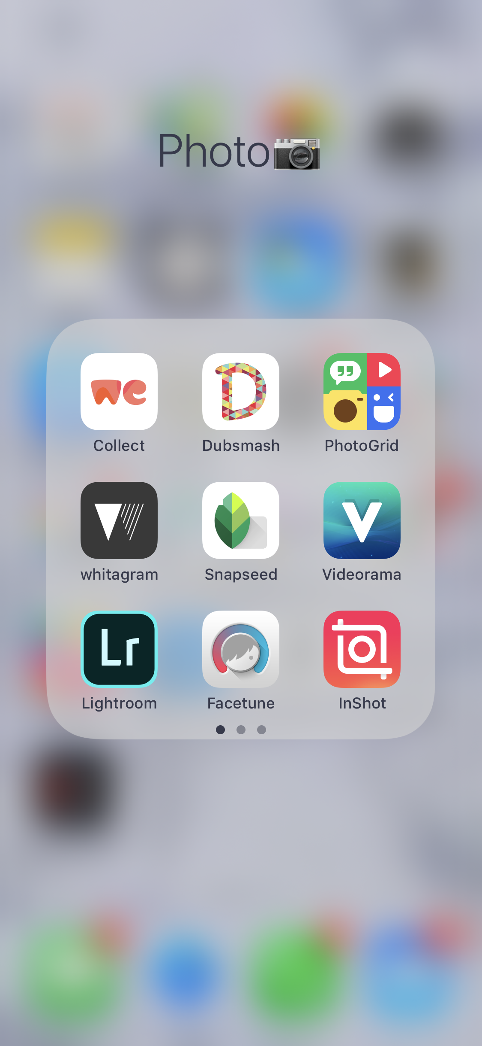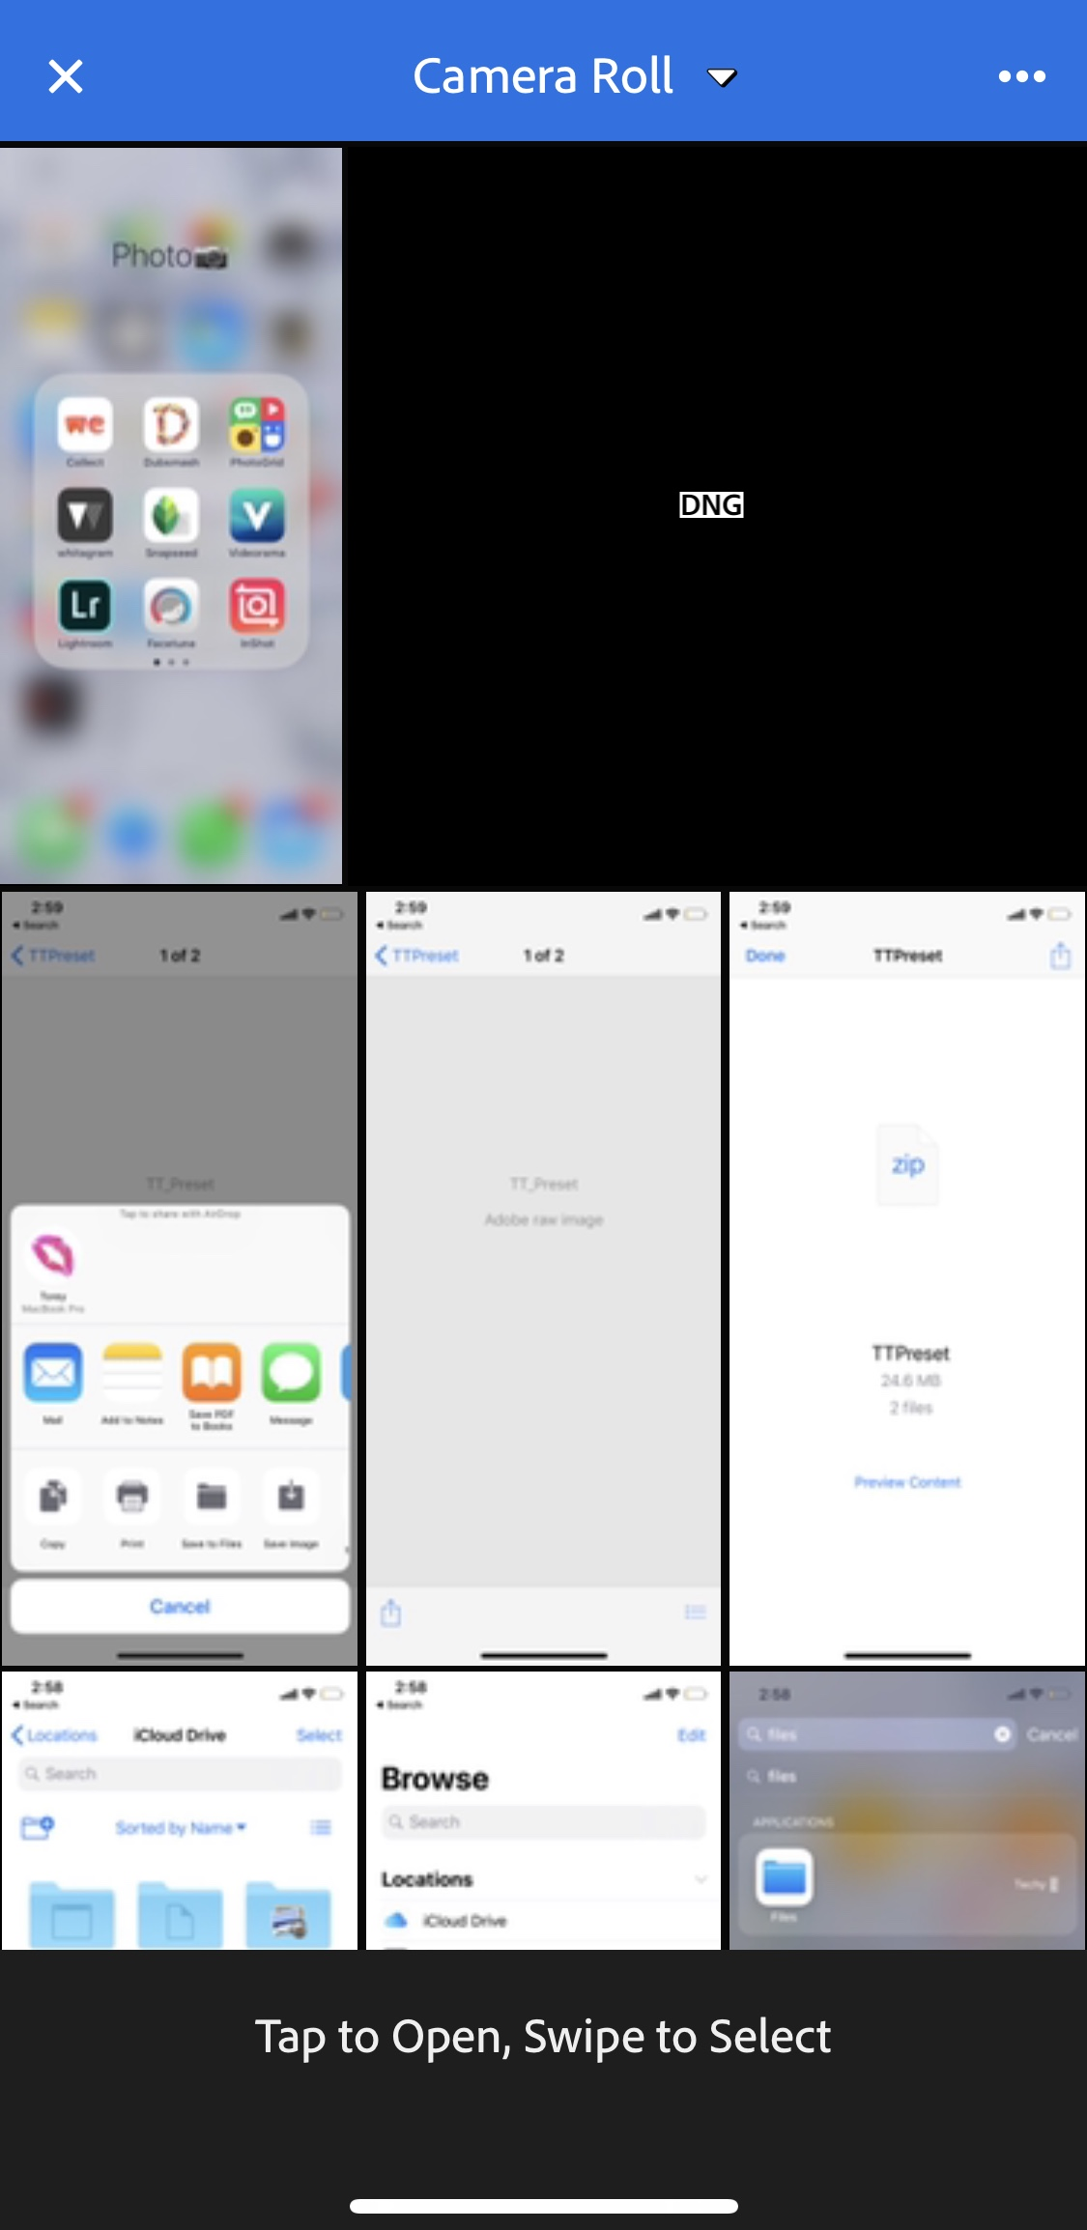

- Tap on the blank .DNG file (don’t be alarmed, it will look blank). Then at the bottom click “Light”.
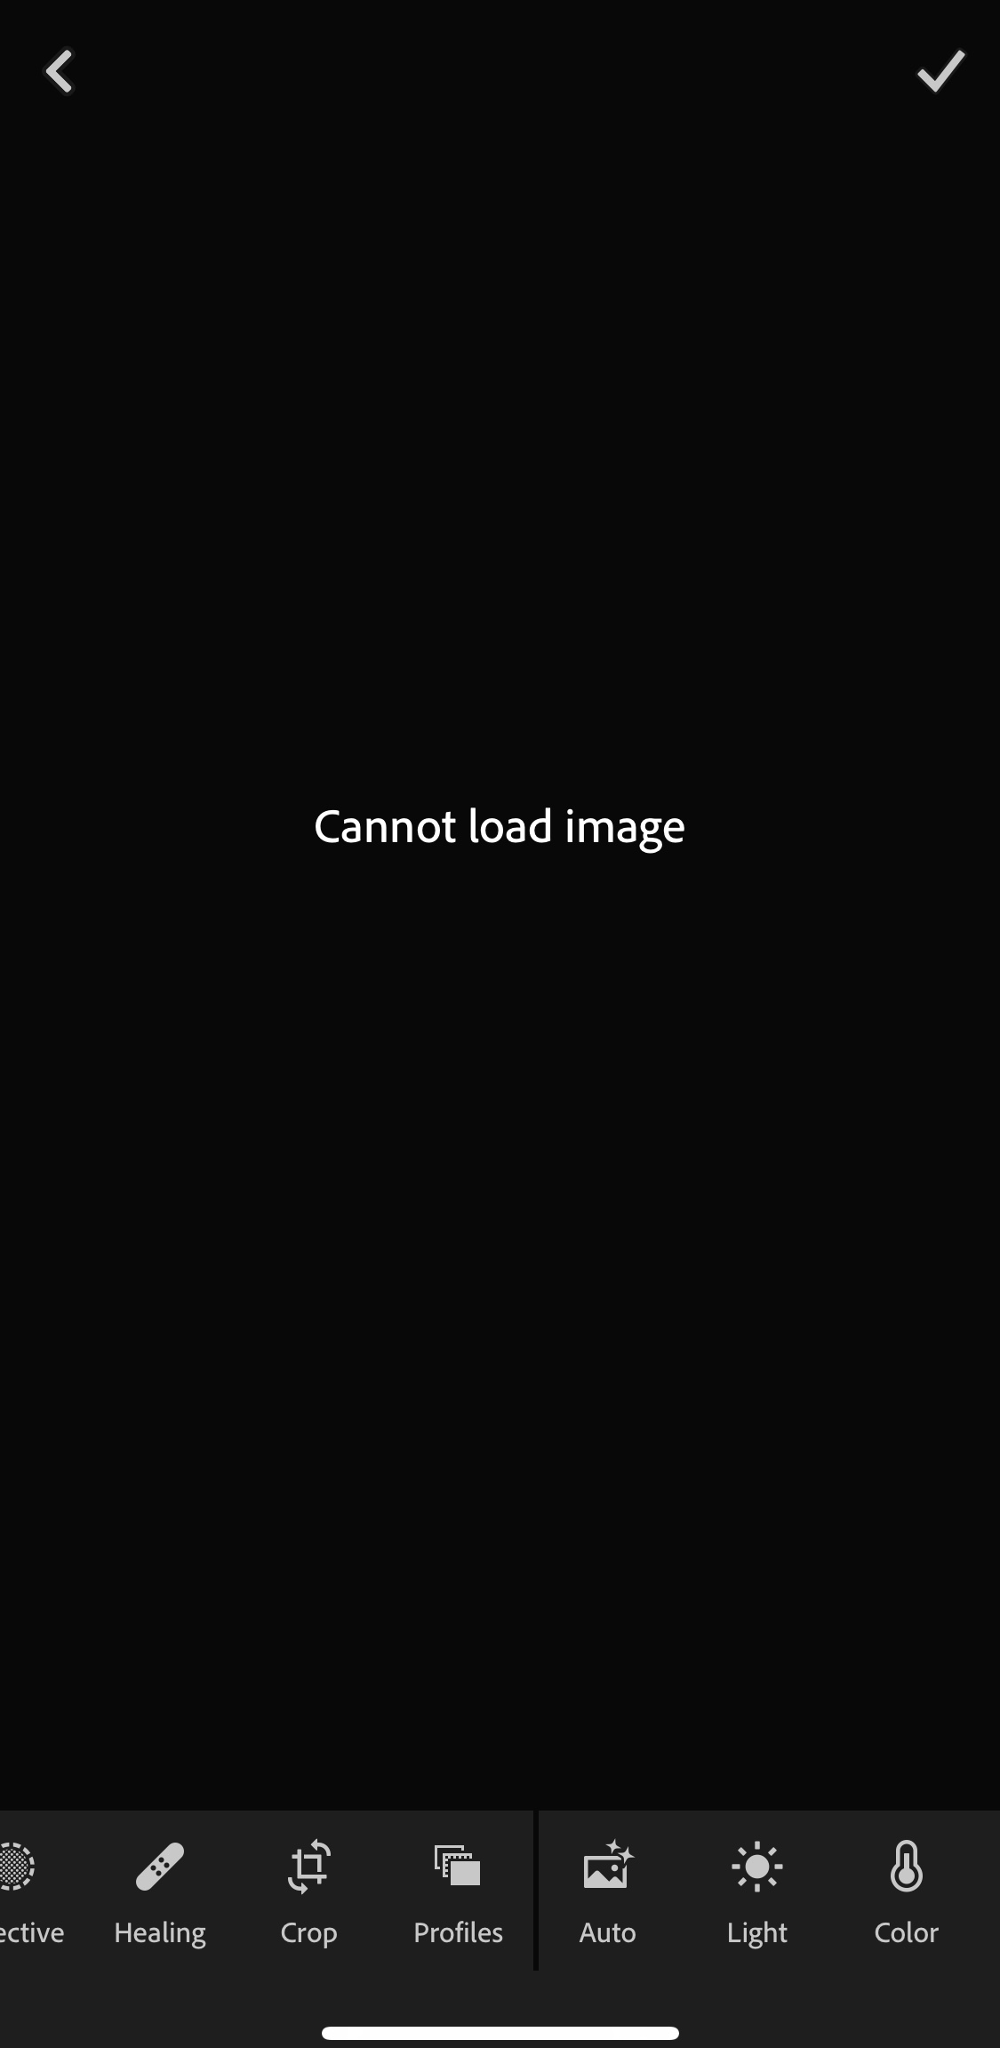

- A picture of Torey will pop up, then just tap the check mark ✔ in the upper right hand corner to add this photo of me to your Lightroom library.
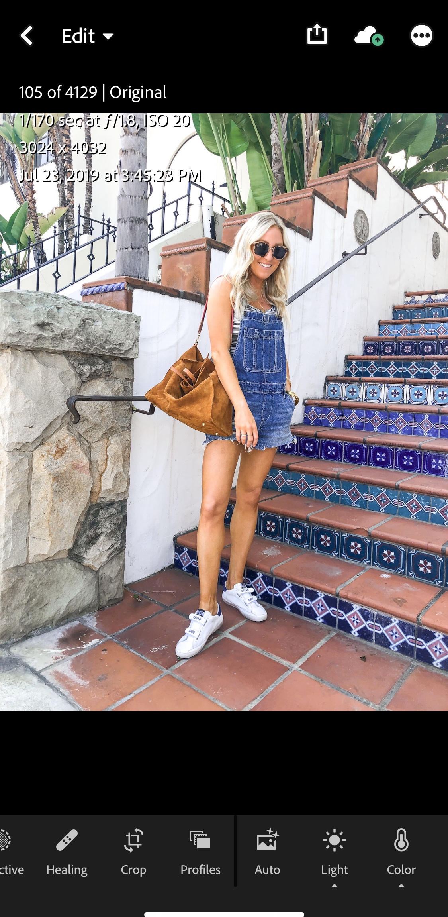

- Then go find this exact same picture of me in your Lightroom library so you can create and save #TTpreset and apply it to YOUR photos

- Once the image reappears, click the 3 dots in the upper right hand corner.
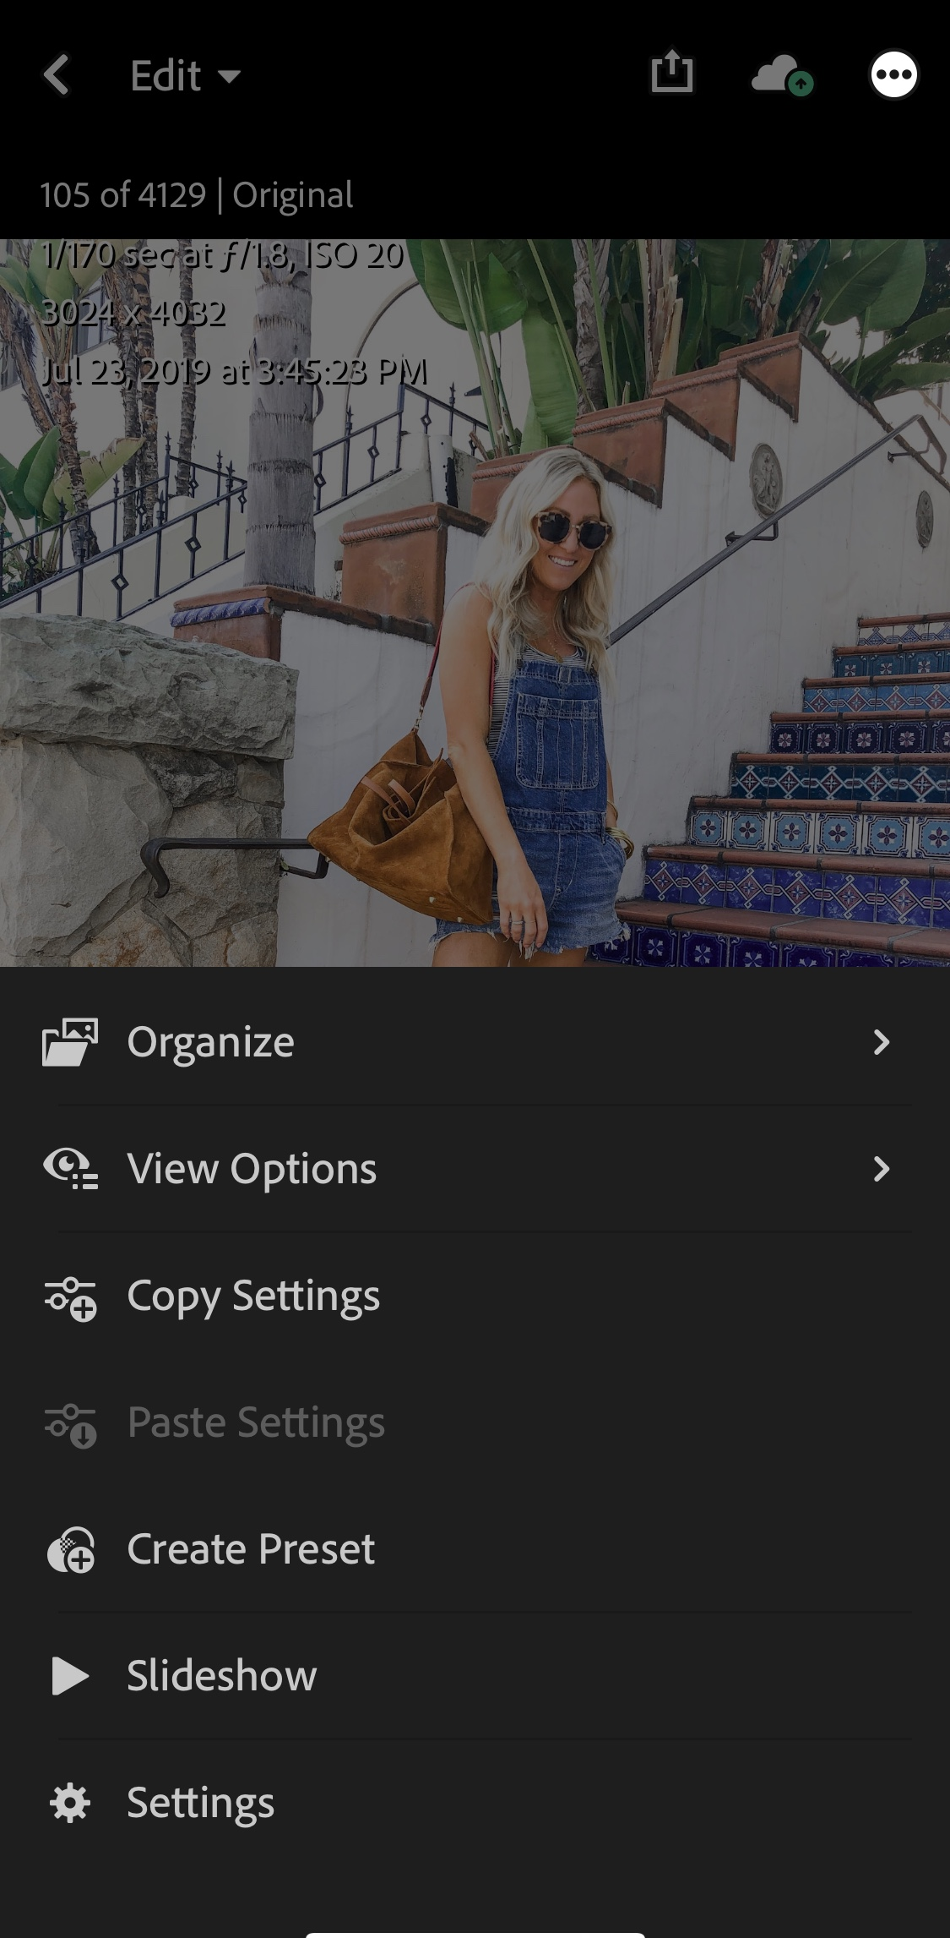

- Now you want save the preset that is connected with this photo by clicking “create preset”

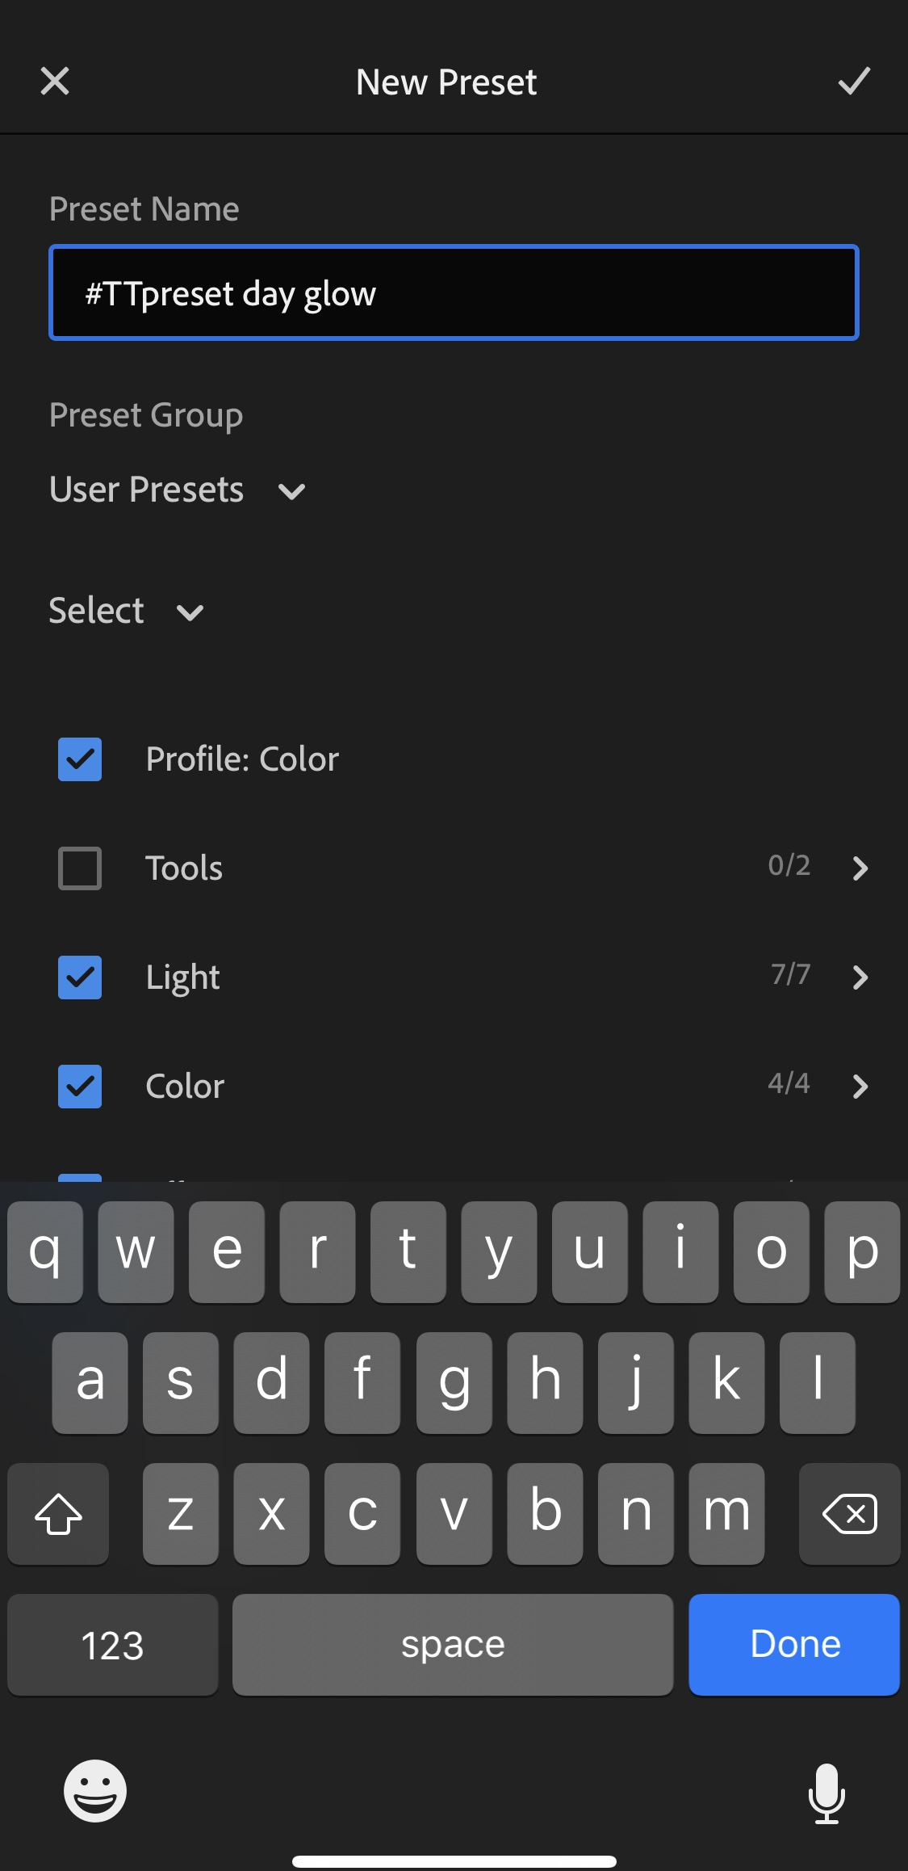

14. Simply type out the preset name #TTpreset day glow to save it under your presets. Click the ✔ in the right hand corner again.

15. It’s official, your photos will look like mine! All you have to do when you want to apply the #ttpreset day glow, is upload your photo in lightroom, scroll over to “presets” and apply it with one-click! Voila!

PHOTO EDITING TIPS:

Please note: lighting can vary from all photo locations, photo angles, etc, so you may need to adjust the brightness and the color of your skin tone so it’s not as orange. How to do this:

- If you feel that your skin tone appears too orange, decrease the orange saturation
- If you want to dim the photo so it’s not so bright and washing you out, simply decrease the exposure and/or highlights.



If you have ANY questions whatsoever, please feel free to email: torey@toreystreasures.com
Don’t forget to tag me @toreystreasures on Instagram and use the hashtag #TTpreset so I can see all your beautiful photos!

